Name ____________________________________________________________ Date ______________________

Figurative Language

Definition | Example
Simile: uses the words ________________ or _____________ to compare one object or  idea with another to suggest they are alike. | 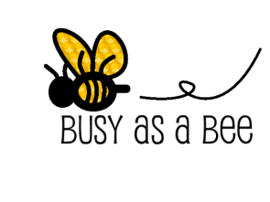
Metaphor: makes a ____________________ comparison - it says you _______________ something. | You are what you eat.
Personification: a figure of speech in which __________________________ characteristics are given to an animal or an object. | The sunlight danced.  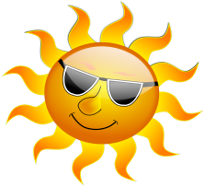
Alliteration: the _____________________________ of the same initial letter, sound, or group of sounds in a series of words. Alliteration includes ________________________________________. | 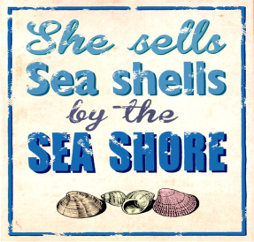
Onomatopoeia: the use of a word to describe or imitate a natural ________________________  or the sound made by an object or an action. | 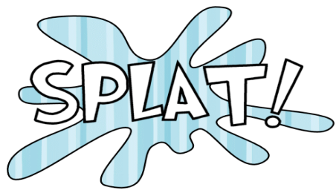
Hyperbole: an _________________________________ that is so dramatic that no one would believe the statement is true. | My backpack weighs a ton!
Oxymoron: a figure of speech that combines two ______________________________ or contradictory ideas. | Jumbo shrimp  